Design Report

1. System Structure Diagram.

There are four models in my project. SignIn/SignUp, Home,Trainer and PersonalCenter.

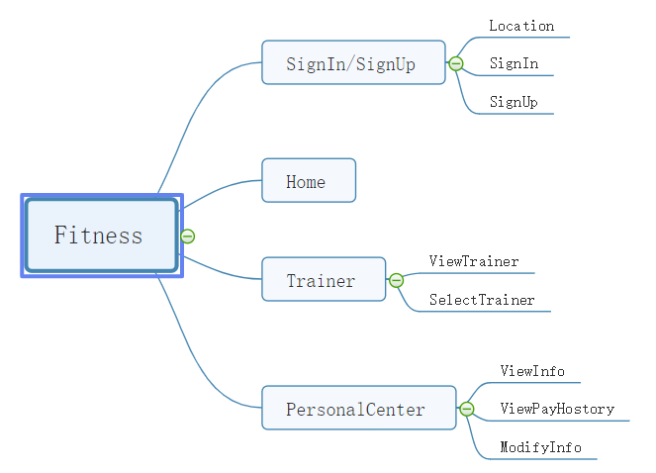

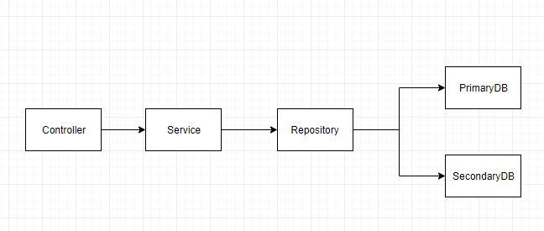

Tools: Spring-boot ,Mysql , Redis

Technology used:Spring-boot,Mysql,Redis,Google Map,Spring-data-jpa,fastJson

Features: multiple tables query, multi datasources, pagination, auditing,caching

* 1. .SignIn/SignUp

Features:Google map, auditing

In this model,user can signIn and signUp or browsing gym location.

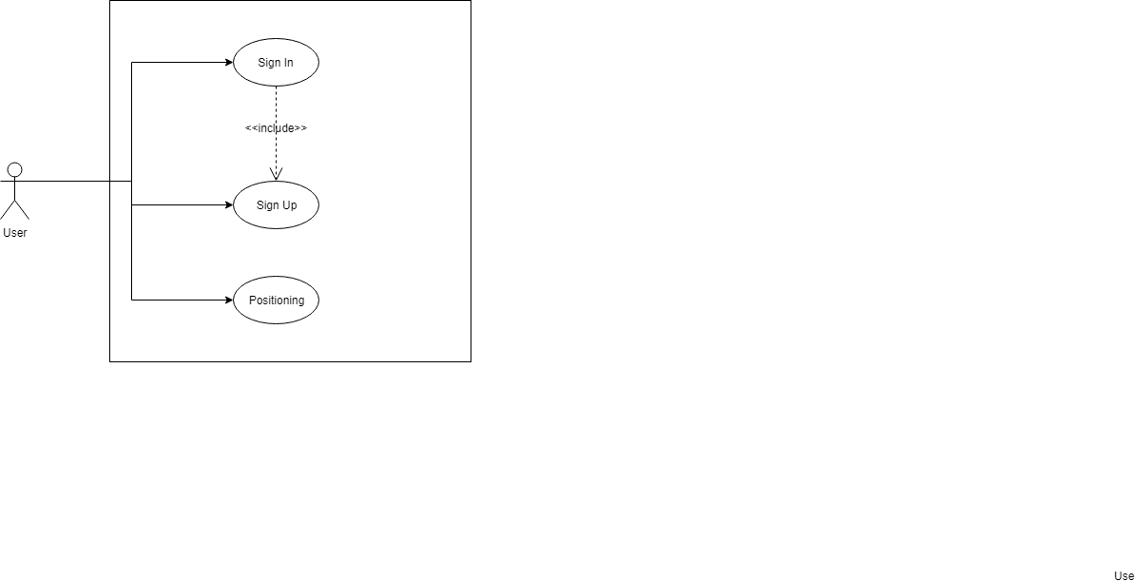

* 1. .home

Features:caching , multiple tables query

In this model,user can browser homepage and next step.

* 1. . Trainer

Features:caching, pagination

In this model,user can browser and select the trainer.

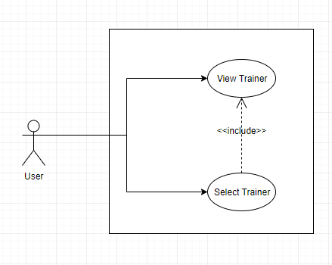

* 1. .PersonalCenter

Features: multi datasources, auditing

In this model,user can browser and modify their info.

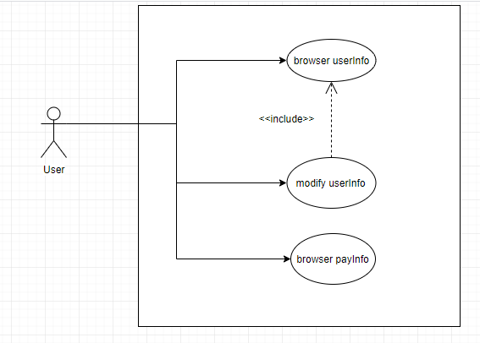

1. Data design
   1. primary dataDB Entity

Customer :

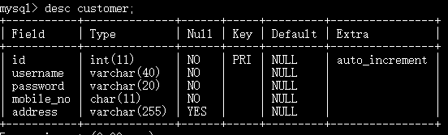

CREATE TABLE `customer` (

`id` int(11) NOT NULL AUTO_INCREMENT,

`username` varchar(40) NOT NULL,

`password` varchar(20) NOT NULL,

`mobile_no` char(11) NOT NULL,

`address` varchar(255) DEFAULT NULL,

PRIMARY KEY (`id`)

) ENGINE=InnoDB AUTO_INCREMENT=12 DEFAULT CHARSET=utf8

Course

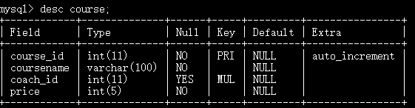

CREATE TABLE `course` (

`course_id` int(11) NOT NULL AUTO_INCREMENT,

`coursename` varchar(100) NOT NULL,

`coach_id` int(11) DEFAULT NULL,

`price` int(5) NOT NULL,

PRIMARY KEY (`course_id`),

KEY `FK2q0hborxuhg47aryws9woqlf1` (`coach_id`)

) ENGINE=MyISAM AUTO_INCREMENT=14 DEFAULT CHARSET=utf8

Coach

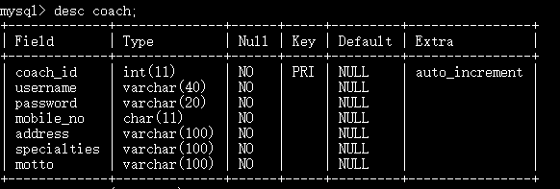

CREATE TABLE `coach` (

`coach_id` int(11) NOT NULL AUTO_INCREMENT,

`username` varchar(40) NOT NULL,`password` varchar(20) NOT NULL,`mobile_no` char(11) NOT NULL,

`address` varchar(100) NOT NULL,

`specialties` varchar(100) NOT NULL,

`motto` varchar(100) NOT NULL,PRIMARY KEY (`coach_id`)

) ENGINE=InnoDB AUTO_INCREMENT=22 DEFAULT CHARSET=utf8

course_customer

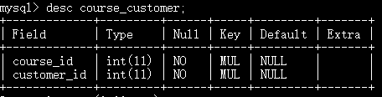

CREATE TABLE `course_customer` (

`course_id` int(11) NOT NULL,

`customer_id` int(11) NOT NULL,

KEY `FKemg9keww81iegt6guwvb1c9nw` (`customer_id`),

KEY `FK19ryot8csdvwt4m5sgxchakdw` (`course_id`)

) ENGINE=MyISAM DEFAULT CHARSET=utf8

* 1. secondary dataDB Entity

ViewLog

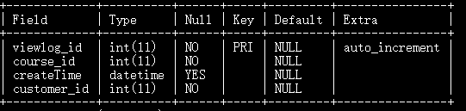

CREATE TABLE `viewlog` (

`viewlog_id` int(11) NOT NULL AUTO_INCREMENT,

`course_id` int(11) NOT NULL,`createTime` datetime DEFAULT NULL,`customer_id` int(11) NOT NULL, PRIMARY KEY (`viewlog_id`)

) ENGINE=MyISAM AUTO_INCREMENT=4 DEFAULT CHARSET=utf8